|  |  |
| --- | --- |
| **Bay Area Geophysical Society Seminar Series** |  |

***Drilling volcanic rifted margins to understand large igneous provinces and associated global warming***

**Dr. Sverre Planke**

Professor of Geophysics, University of Oslo

CEO/founder, Volcanic Basin Energy Research

**September 30th, 2024, 1:00 PM PST**

**ONLY on** [**Zoom**](https://lbnl.zoom.us/j/97894325806?pwd=hbvNQCgFpkhJuavLrtTn3a4dQNLfdt.1)

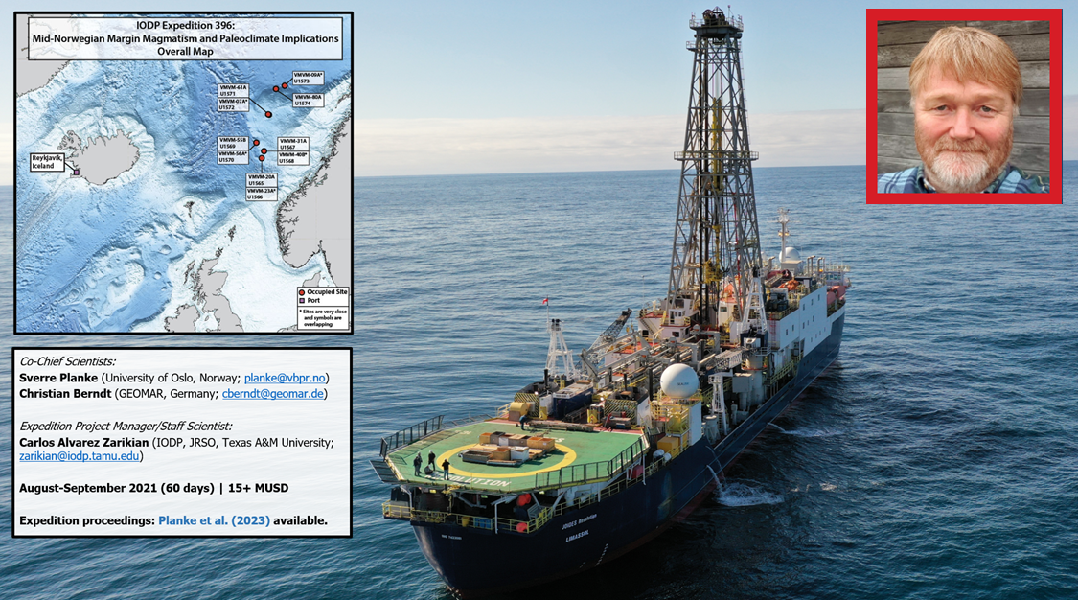**Abstract:**

Continental breakup is a rare, but fundamental Earth event driven by massive internal forces. The splitting of Europe from Greenland some 56 million years ago was likely triggered by hot material rising from the deep mantle, forming a large igneous province. The breakup magmatism was associated with a global warming and extinction event, the Paleocene-Eocene Thermal Maximum (PETM). IODP Expedition 396 successfully drilled 20 holes on the mid-Norwegian continental margin to better understand continental breakup processes and to test the hypothesis that associated voluminous magmatism triggered the PETM. Hole locations were carefully selected on conventional and high-resolution 3D seismic data. In total, > 4 km of sediments and volcanic rocks were drilled, recovering 2 km of core. High-resolution palynology and isotope geochemistry document that the hydrothermal venting took place near the start of the PETM, supporting the hypothesis that the global warming event was triggered by shallow-water eruption of greenhouse gases formed by heating of organic-rich sediments intruded by magmatic sills.

In conclusion, scientific drilling has provided essential data to document how the Earth’s internal processes have influenced the environment and life in deep time. To understand the environmental changes in the future, it is critical to keep on drilling the ocean basins to test new hypotheses and to discover our geological past.

**Author:** Sverre Planke is the CEO of Volcanic Basin Energy Research as (VBER) and a Professor II at the Department of Geosciences, University of Oslo, Norway. He is a geoscientist with research focus on the processes and structure of volcanic rifted margins and volcanic basins based on integrated geological, geophysical, and theoretical methods. Sverre is a co-founder of VBER (1999) and P-Cable 3D Seismic (2007). He holds a B.Sc. in geological engineering (1985) and a M.Sc. in geophysics (1987), both from the University of Utah, and a Ph.D. in marine geophysics (1993) from the University of Oslo.

**Zoom meeting information:**

Zoom ID: 978 9432 5806

Password: 792833